

**School of online and distance learning**

P.O Box 58182-00200

NAIROBI-KENYA

[info@africadevelopmentresources.org](mailto:info@africadevelopmentresources.org)

Tel. +254708257424/723305358

Your ref:

Aipms/131/2018

Our ref: 14/06/2018

Name: Katiba Palek Theng

P.O Box 58182-00200

Dear Katiba,

**NOTIFICATION OF ADMISSION FOR A DIPLOMA COURSE**

I refer to your application to pursue a course leading to an award of DIPLOMA IN WATER, SANITATION AND HYGIENE in the SCHOOL OF DISTANCE LEARNING during the 2018 academic year.

On behalf of the distance learning school and the management of the institute, I am pleased to inform you that you are eligible for admission into the programme. Admission to our program is very competitive and we scrutinize each application carefully. We believe that a stimulating, intellectual discussion between students and our institution is a necessary ingredient in adding value to the skills and knowledge endowed by one. I have recommended that the school of distance learning admits you because we think that you will be able to make a contribution to our research dialogue while developing self.

You are joining a very distinguished institution that has been delivering timely and professional capacity building services to a wide variety of organizations in the development sector. Your choice to attend AIPMS for a development course is perhaps the wisest choice of your professional career.

We encourage you to be in contact with us between now and 27th April 2018.

* First you need to notify us as soon as possible but not later than 27th April regarding whether or not you plan to accept this offer.
* Your advisor in this programme is Karegwa Muchiri and we do encourage that you contact him within the next few days to get acquainted, to discuss your research interests, and to begin to plan your academic program
* Note that fees is payable in full on or before commencement of each semester and we do not allow for registration without paying full fees. All fees should be paid by Direct Cash Deposits, Electronic Funds Transfer (EFT) or RTGS to the following account

**Account Name:        Africa Center for Project Management  
Bank Name:      CFC Stanbic Bank Ltd,   
Account Number:    0100004064059 (KSH)   
Branch:             Warwick Service Centre  
Swift code:         SBICKENX  
Bank code: 31**

Deposits may also be made at any branch of CFC Stanbic Bank, Warwick Service Centre Branch. We allow for institutional cheques and Bankers cheque but do not allow personal cheques.

The entire program is very proud to be able to attract so many outstanding scholars like you. We look forward in meeting with you virtually and developing with you a sound partnership in teaching and learning for your future.

NOTES

1. All fees should be paid before registration is effected
2. All assignments should be handed in, in good time and a follow up made on marks awarded
3. To qualify for graduation one should undertake all assessment tests and prove to the examiners that the student has understood the content of the course
4. Research funds are subject to change depending on the course and the project to be done
5. The fees structure for your course is indicated in the invoice attached and may be subject to change without any prior notice

Yours faithfully,

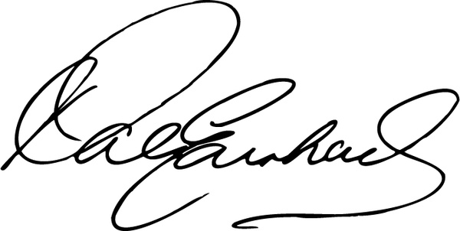

Karegwa Muchiri

Director, distance learning school